TITLE PAGE

**Patterns of influence in wild moving meerkat groups (working title)**

Baptiste Averly1,2,3,, Vivek H. Sridhar2,3,, Vlad Demartsev1,2,3,4, Gabriella Gall1,2,3,4,5, Marta Manser4,5,*, Ariana Strandburg-Peshkin1,2,3,4,*

1. Department of Biology, University of Konstanz, Konstanz, Germany
2. Department for the Ecology of Animal Societies, Max Planck Institute of Animal Behavior, Konstanz, Germany
3. Centre for the Advanced Study of Collective Behaviour, University of Konstanz, Konstanz, Germany
4. Department of Evolutionary Biology and Environmental Studies, University of Zurich, Zurich, Switzerland
5. Kalahari Meerkat Project, Kuruman River Reserve, Northern Cape, South Africa

*joint senior author

**ABSTRACT**

**INTRODUCTION**

In social animals, individuals often have heterogenous contributions to group decisions. In a given instance, group members whose actions cause others to change their behavior can be said to exert influence, regardless of their intention, but the distribution and consistency of influence can vary between individuals over multiple instances (Strandburg-Peshkin et al. 2018; Garland et al. 2018). Influence patterns have proven hard to assess and compare between social groups in the wild for a number of reasons. First, animal groups differ in size and composition, social structure, type of movement and cohesion mechanisms and thus display a wide variety of influence patterns. Second, individual influence within a given group can be highly variable and depends on environmental or social context, as well as transient traits like physiological status or foraging success. It is often non-trivial to define and quantify influence in social systems, as one requires knowledge about the decision-making mechanisms at play and about the type of individual actions that can influence the decisions of others. In the context of movement decisions, these cues include position in space, movement in a given direction, as well as specific vocalizations. However, while models and lab experiments have shown that the movement of a given individual in a group is strongly influenced by the relative position of its neighbors (Couzin et al. 2005), it is unclear to what extent this is true in the wild. Finally, since individual influence is relative to the type of decision being considered, influence over one type of group decision does not necessarily translate into influence over other types. For instance, it is not well known whether the individuals that have high influence over the group’s direction of movement also have more influence on the group’s speed or timing of departure. Influence is therefore a highly versatile notion and it is crucial to define the context in which it is looked at and to have a thorough understanding of the biology of the species of interest to assess it accurately.

In recent years, there has been a surge in studies trying to assess influence dynamics in wild moving animal groups. These studies have mostly been made possible by the reduction in cost and size of tracking technologies which allows the simultaneous recording of multiple individuals (Hughey et al. 2018). Such studies have investigated the influence of individual animals over direction of travel (Kerth et al. 2006; Nagy et al. 2010; Giuggioli et al. 2015) and timing of departure (Strandburg-Peshkin et al. 2015; Tokuyama and Furuichi 2017; Montanari et al. 2021), as well as the positioning of individuals at the front of the group (Lewis et al. 2011; Van Belle et al. 2013; Smith et al. 2015). These studies have deepened our understanding of decisions-making mechanisms during movement and highlighted the diversity of influence patterns in nature from mostly distributed (e.g. in baboons, Strandburg-Peshkin et al. 2015) to mostly concentrated systems. A positive link between influence and social rank has also often been established (Smith et al. 2015), though systems with influential subordinates are also found (Papageorgiou and Farine 2020). Few studies have looked at several measures of influence within one system, for example to evaluate if individuals with influence over direction of movement also have influence over speed or travel (Katz et al. 2011; Herbert-Read 2016), or to validate the assumption that frontmost individuals have more influence (Pettit et al. 2015; Jolles et al. 2017). However, these studies are scarce, particularly for wild animal groups.

Wild meerkats (*Suricata suricatta)* are a very interesting study system to investigate individual influence on movement decision, as thesesocial mongooses have both a very particular social structure and constantly have to make movement decisions, as they travel as a cohesive group. Meerkats live groups of up to 50 individuals in the arid parts of southern Africa (Doolan and Macdonald 1997; Manser and Clutton‐Brock 2016). Te, but there is among the remaining,. All group members sleep together inside communal burrows at night and continually move as a highly cohesive unit throughout their 2-5 km2 territory (Kranstauber et al. 2019) in search of food during the day. Group splits happen very rarely (Strandburg-Peshkin et al. 2019) and never last more than a couple of hours. Meerkats are opportunistic generalists, their diet being mainly composed of small invertebrates that they dig out of the ground (S. Doolan and Macdonald 1996), therefore food resource is not clumped like for several other social species (Ref capuchins, dolphins,…?) but rather distributed across the desert landscape. This particularity is reflected in the groups’ movement dynamics: rather than alternating clearly distinct foraging and moving phases, the whole group is slowly travelling across the environment in a cohesive manner, while individuals forage independently a few meters apart from each other. However, it is not yet understood how the group makes decisions about direction of movement, movement speed or timing of departure and how individual animals influence these decisions. Vocal communication likely plays a big role, as it was shown that specific can initiate group movement

(Bousquet et al. 2011), whereas others are given to maintain group cohesion (Gall and Manser 2017). Further, several studies report that dominant indiviuals have more influence on non-breeding activities such as foraging (Bousquet and Manser 2011; Gall et al. 2017; Strandburg-Peshkin et al. 2020).

Here, we implement a simple method to infer individual influence from very-high resolution GPS tracks of wild meerkats in five different groups of varying size. Because of the particular type of collective movement of meerkats described above, this method does not focus on particular events at the transition between foraging and moving, but rather aims to capture an aggregated measure of influence over continuous foraging times. We designed it to explicitly differentiate and compare influence over two complementary components of moving animal groups, direction of movement (=**turning influence**) and speed of movement (=**speeding influence**), as well as two potential cues, position within the group and movement in a given direction. Since frontmost individual are often assumed to have more influence during collective movement, we compared our metrics of influence with the proportion of time spent in the front half of the group, to try and assess if this is true in meerkats. Our questions are thus the following: (1) Are meerkats more influenced by the position of others within the group or their movement in specific directions? (2) Are there consistent patterns of influence between age classes across different meerkat groups? (3) Do individuals with high influence over direction of movement also have a high influence over speed and vice-versa? (4) Are individuals with more turning or speeding influence also the ones who are generally more in the front of the group?

**METHODS**

**Study site and data collection**

*Study system*

The study was conducted at the Kalahari Meerkat Project (KMP) within the Kuruman River Reserve in South Africa (26°58′S, 21°49′E, (Clutton-Brock et al. 1999) , where 7-15 meerkat groups are brought to a very high level of habituation to humans and monitored on a regular basis all year round. We collected simultaneous, high-resolution (1 Hz) movement data on the majority of individuals within five distinct habituated meerkat groups: HM17 (7 individuals) in August and September 2017, HM19 (18 individuals) in June and July 2019, L19 (19 individuals) in August 2019, ZU21 (13 individuals) in May 2021 and NQ21 (11 individuals) in August 2021. We chose the groups with the highest levels of habituation among the monitored population to enable collars to be deployed without the need for capture (see below). Individuals were attributed one of six different statuses, based on ongoing classification at the KMP: dominant females (one per group), dominant males (one per group), other adults (2+ years), yearlings (<2 years), sub-adults (<1 year) and juveniles (<3 months). Three individuals were present both in HM17 and HM19, with different statuses (see Supplemental Table 1).

*Tag design*

To simultaneously record the trajectories of all individuals in a meerkat group, we designed small (<25 g) collars consisting of a GPS unit (Gipsy 5 in 2017 and 2019, Axy-Treck Mini in 2021, Technosmart, Colleverde, Italy) and its battery (ER14250M) fixed on 5 mm-wide leather strap and protected from shocks and sand by wrapping in parafilm and covering with 2-part epoxy glue. The length of the strap was adjusted individually for each meerkat based on prior neck measurements. The closing mechanism consisted of 2 magnets (1*5*5mm) glued to 3-D printed plastic clasps at each end of the leather strap, designed to be able to close easily but to require human intervention to open. Completed collars weighed between 22 and 25g, which was never more than 5% of the animal’s body mass. Once fitted on a meerkat, the GPS board rested on back of the neck, with the whip antenna pointing down the back of the individual (Figure 1a).

*Collar deployment, duty cycle and retrieval*

Collars were deployed in the morning hours, when meerkats were at their communal sleeping burrow to warm up in the sun or groom each other prior to foraging. Collars were deployed after carefully approaching and grooming the meerkat and only if the animal remained stationary and showed no sign of discomfort or attempted escape. Some individuals were collared while drinking water which was presented for distraction. No more than two attempts of collaring were done per day per individual to prevent de-habituation. After successful collaring, individuals were observed for at least ten minutes and the collar was removed if they exhibited any kind of unusual behavior (e.g. continued scratching at the collar). At the end of data collection, collars were taken off in the same way as they were deployed. All GPS units in a given group recorded at 1 GPS fix/second for 3 hours every day, either in the morning after the group had left the sleeping burrow, or in the afternoon before returning to it depending on the deployment round (i.e. times when meerkats are foraging freely within their territory and are the most active). Recording duration for a single deployment round ranged from 6 days to 10 days depending on GPS-battery life. See Supplemental Table X for detailed information on group composition and deployment timing.

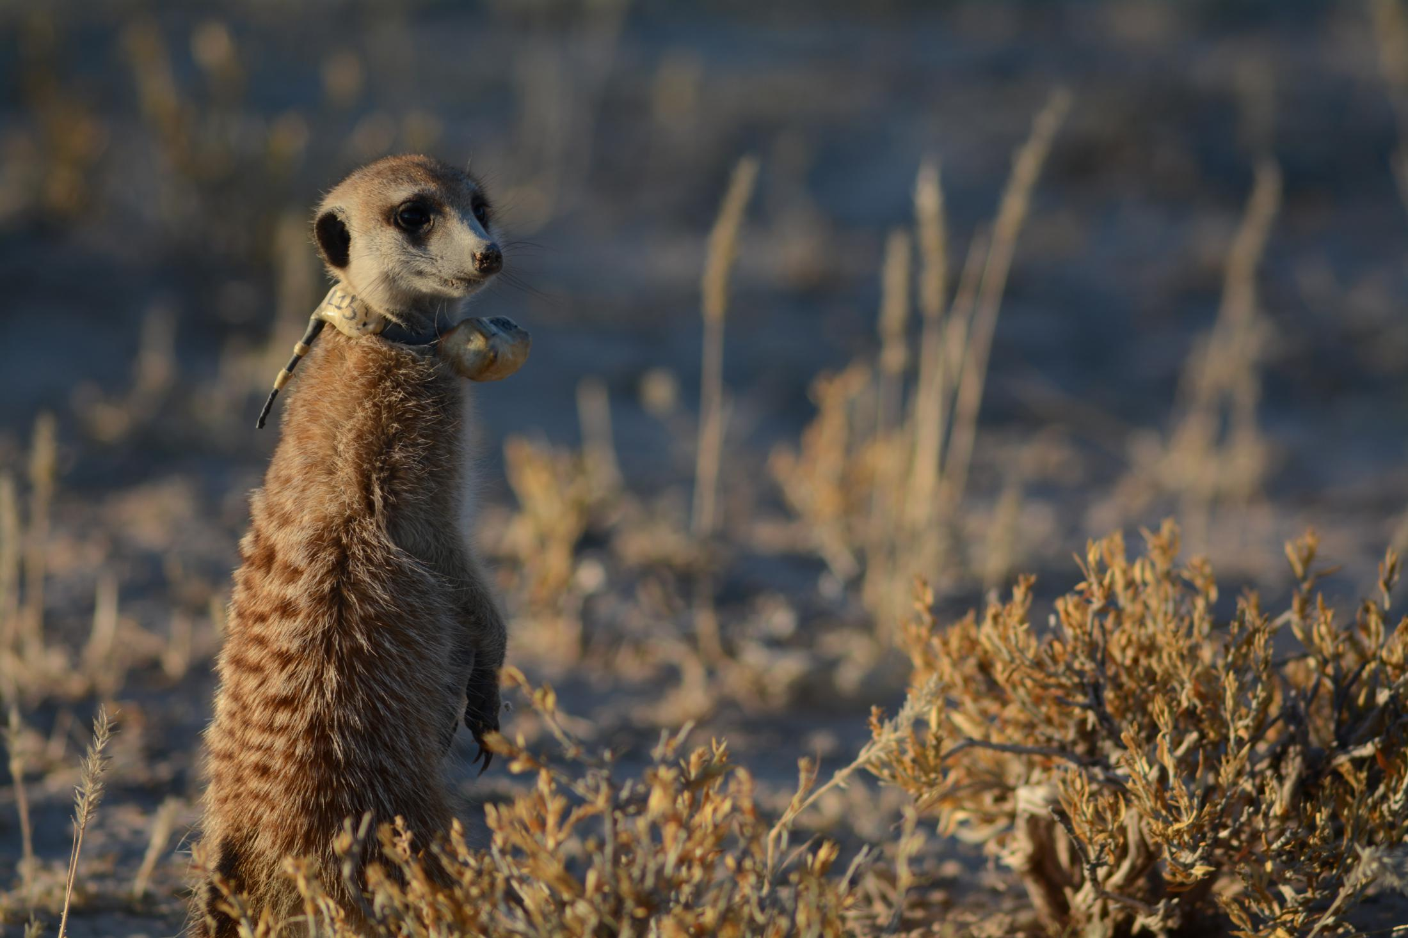

**battery**

**GPS**

**unit**

**antenna**

*Focal recordings of untagged individuals*

Due to their small size, some juvenile individuals could not be collared and their movements were thus recorded by human observers. A GPS tag equivalent to those deployed in collars was strapped to the end of a telescopic pole and thus kept within 1 meter of the juvenile for the duration of each session. At the same time, the observer was vocally describing the meerkat’s behavior in a handheld microphone. We then processed the data of the uncollared exactly in the same way as data from meerkats wearing a collar (see below).

*Scans*

We noted the occurrence of specific events (e.g. predator alarm, encounter with another group, etc…).

*Incomplete group recordings*

Due to GPS tag battery failure and unsuccessful collaring attempts, not every adult meerkat group member was recorded every day. adult group membersMissing juveniles was tolerated, as .. ?

*Data pre-processing*

To increase GPS reliability and reduce sampling biases, we

discarded all data recorded 30s before signal loss and 30s after retrieval when GPS signals were not recorded continuously. Similarly, we removed fixes with fewer than 5 satellites detected.  We also removed data suggesting unrealistic speeds (> 10 m displacement between 2 fixes 1 second apart) as these likely represented GPS errors. Coordinates were converted from WGS84 to UTM S34 to allow for easier spatial analyses.

We also removed periods of predator alarms and one instance of encounter with another group, as these specific contexts are likely to be non-representative of typical meerkat group movement during foraging.

If individuals separated from the rest of the group (e.g. when exhibiting babysitting behavior at the communcal burrow or when travelling on their own/”roving”, a behavior displayed by adult males before leaving their natal territory), we discarded the GPS track of that given individual was discarded. One full day was removed from the analysis because of a rare and highly unusual situation (the dominant male had left the group with two other adult males), which likely affected the group’s usual movement behavior.

**Analysis**

*Summary of the process:*

In order to assess the consistency of individual influence from the GPS tracks, we defined two complementary metrics, **turning influence** representing an individual’s influence over the direction of travel of the group (along the left-right axis of movement, figure X), and **speeding influence** representing an individual’s influence over the speed of travel of the group (along the front-back axis of movement). Each metric comes in two different versions, depending on what type of cue from the individual of interest is considered (position within the group or movement in a given direction). **Position turning influence** therefore tries to answer the question “does the left-right position of a given individual influences the group’s direction of travel?” and is defined as the probability that the rest of the group turns toward a given direction (left or right) as a function of the left-right position of an individual, while **movement turning influence** tries to answer the question “does the left-right movement of a given individual influences the group’s direction of travel?” and is defined as the probability that the rest of the group turns toward a given direction as a function of the individual’s speed along the left-right axis of movement. Similarly, **position speeding influence** tries to answer the question “does the front-back position of a given individual influences group speed?” and is defined as the probability that the rest of the group speeds up as a function of the front-back position of an individual, while **movement speeding influence** tries to answer the question “does the front-back movement of a given individual influences group speed” and is defined as the probability that the rest of the group speeds up as a function of the difference between individual and group speed along the front-back axis of movement.

We separately modelled the curves of each of these four metrics for each recorded individual using a slightly modified version of the logistic function, and used these models to attribute four influence scores to each individuals. We then performed Generalized Linear Mixed Models (GLMMs) to compare the values of each influence scores between classes.

*Detailed process:*

We followed the following process to compute the influence metrics of all recorded individual within each five groups:

We first calculated groups’ and individuals’ movement characteristics by discretizing and summarizing the direction and speed of their travel. We computed the **group’s centroid track** by averaging the position of all individuals recorded other than the focal at each time point (figure 2a). For every time point t, we then calculated two velocity vectors of the centroid (figure 2b): the past velocity vector was the direction and speed measured from the position at time t (henceforth current position) to the most recent position that was at least 10 meters away (henceforth ‘past position’), and the future velocity vector was the direction and speed measured from the current position to the soonest upcoming position that is at least 10 meters away (henceforth ‘future position’). We chose 10 meters as the step length for spatial discretization as this seemed to be a good balance between spatial resolution of the GPSs and temporal resolution of the behaviors studied. As a sanity check, we performed the whole analysis again with thresholds of 5, 15 and 20 meters and got similar results (see supplements). For each time step, movement of the group was defined as either turning left or turning right (future direction of travel), and either speeding up or slowing down (future speed of travel), based on the relative difference between the group centroid’s future and past velocity vector.

The group centroid’s current position and the group centroid’s past velocity vector were also used to define the x-axis of an orthonormal basis relative to which the position and movement of the focal individual could be computed (henceforth centroid reference frame, figure 2c): we calculated the past velocity vectors of the focal individual at each time point, similarly as for the group vectors, and converted it to the centroid reference frame. From this, we computed four variables corresponding to the four different metrics of influence:

* the y-value of the individual’s past position (=left-right position, corresponding to **position turning influence**)
* the y component of the individual’s past velocity vector (=left-right movement, corresponding to **movement turning influence**)
* the x-value of the individual’s past position (=front-back position, corresponding to **position speeding influence**)
* the difference between the x component of the centroid’s past velocity vector and the x component of the individual’s past velocity vector (=front-back movement, corresponding to **movement speeding influence**)

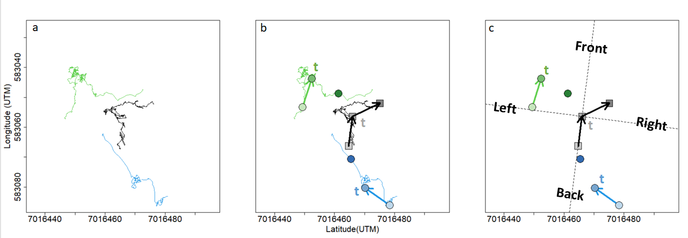Figure 2. Summary of data processing for a given time point. (a) Portions of meerkat movement trajectories collected from GPS collars. Green and blue lines represent the trajectories of two example individuals over a 20 minutes interval. Black line represents the trajectory of the group centroid over the same time-interval, obtained by averaging the coordinates of every individuals in the group (only two individuals represented). (b) At time t, velocity vectors are calculated from the points 10 meters in the past and 10 meters in the future. Lighter symbols represent positions earlier in time, darker ones represent symbols later in time. (c) The velocity vector of the centroid from the past is used to define an orthonormal basis (dashed line) relative to which the position and movement of all individuals are calculated. Based on the centroid velocity vector from the future, the group is defined as either turning left or turning right, and either speeding up or slowing down at time t. Influence metrics are derived from the individual velocity vectors from the past. In this example, the blue individual would have a positive position turning influence at time t because it was on the right side of the group before the group turned right, but a negative movement turning influence because it was moving towards the left before the group turned right. It is the opposite for the green individual.

Exploratory analyses had shown that the probability of the group to turn right increased sharply as individual position or movement towards the right increased, before plateauing (figure 3), and likewise, group probability to speed up increased as individual’s speed, front-back position or movement also increased (see supplements).

We therefore modelled each of the four influences as a binary group response as a function of a continuous individual predictor: (1) probability of the group to turn right as a function of individual left-right position, (2) probability of the group to turn right as a function of individual left-right movement, (3) probability of the group to speed up as a function of individual front-back position, (4) probability of the group to speed up as a function of individual front-back movement.

The models used were a modified version of the logistic function (equation 1):

Where α represents the probability that the group is influenced by the focal individual at a given time point, β is the logistic growth rate (steepness) of the curve, and γ represent the baseline probability of the group either turning right or speeding up. We therefore consider that the group movement outcome (either turning left/right or speeding up/slowing down) has a probability α to be influenced by a given individual, in which case it follows a standard logistic function (first term of the equation), or is decided regardless of the position or movement of the focal individual, at a probability (1- α). γ was set as 0.5 for the two turning influence metrics (equal probability to turn left or right), and as the overall probability of a given group to speed up over all time points for the two speeding influence metrics .

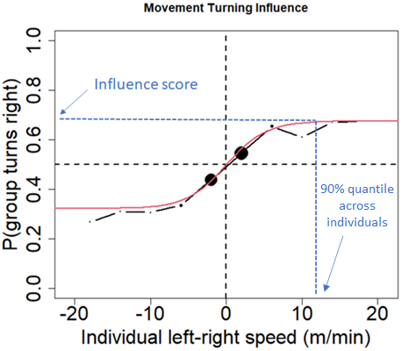We computed the fitted values of α and β for each of the four influence metrics by maximizing the log-likelihood of the functions. To compare influence scores across individuals, we selected reference values for individuals positions and movements relative to the group (90% quantile of the respective variables across all individuals) and used the predicted probability from the model for that reference value as a score to assess that individual’s influence (figure 3). This influence score therefore corresponds to the probability that the group is positively influenced by the focal individual for a fixed value of position or speed relative to the group centroid.

Figure 3. Probability that the group turns right relative to its past direction of travel as a function of the speed of an example individual along the left-right axis. Positive and negative x-values indicates that the individual was moving towards the right and left of the group relative to past direction of travel, respectively. Black curve shows the real data (binned every 4 x-units), red curve shows the fitted line from the model, blue dotted lines show the influence for that individual.

Once we had calculated the four influence scores for all individuals within the five groups, we performed GLMMs with each influence score as the response variable, social status as a categorical predictor and group as a random effect to test if social status was correlated with influence scores .

To account for both the influence of position and movement of an individual on the group in one model, we also modelled the probability of the group to turn (or speed up) as a function of individual left-right (or front-back) position and individual left-right (or front back) movement (equation 2).

We fitted the two models across all individuals instead of separately for each individual.

*Proportion of time in the front:*

In order to see how our influence metrics related to another, commonly used metric of influence, we calculated the proportion of time each individual was spending in the front half of the group (i.e. its front-back position or x-value within the centroid reference frame, was positive). In order to see the variation in the propensity to be in the front between individuals and across groups, we computed the proportion of time points an individual was in the front half in time segments of one hour. We then assessed the correlation between the proportion of time spent in the front for each individual and their turning and speeding influence scores.

**RESULTS**

**Influence of individual position VS individual movement:**

Using the model described by equation 2, we found that across all individuals, individual left-right speed had a much greater influence over group turning than individual left-right position (figure 4a). Similarly, the probability of the group to speed up was influenced more by individual front-back movement than by individual front-back position (figure 4b.)

Because these results show that individual movement is a more important cue than individual position in influencing the rest of the group’s direction and speed, we present here mainly the results of the movement turning and movement speeding influence.

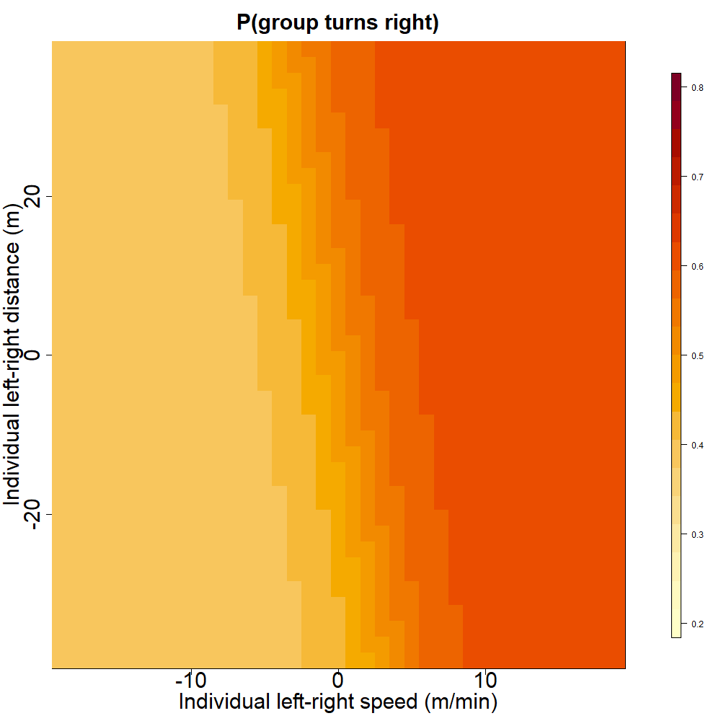

a.

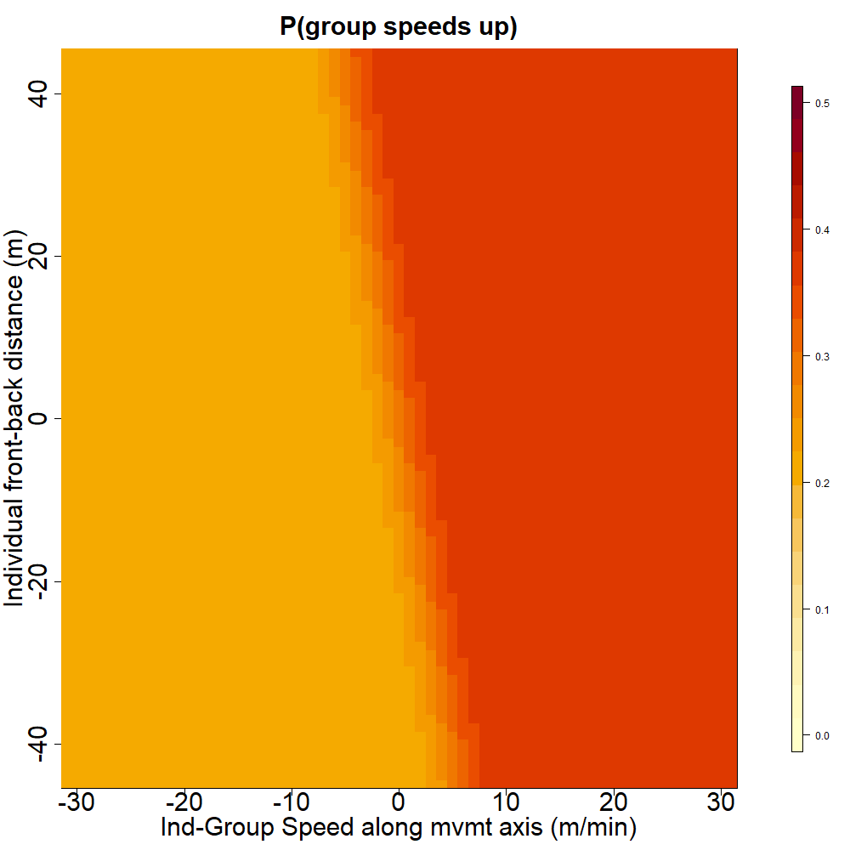

b.

Figure 4. (a) Turning influence: Probability that the group turns towards the right relative to its past direction of movement as a function of individual left-right position and left-right movement. (b) Speeding influence: Predicted probability that the group speeds up relative to its past speed, as a function of individual position and group-individual difference in speed along the front-back axis of travel. Extent of the axes correspond to the 99% quantiles of the variables across all indviduals.

**Movement turning influence and movement speeding influence scores across statuses:**

We found a significant effect of status on movement turning influence score, with group taken into account as a random factor (figure 5a, F = 5.19 ; DF = 40 ; p-value = 0.0018), with the dominant female’s score consistently being the highest or second highest of the group. Post-hoc Tukey tests (see Supplements) showed that the score of dominant females was overall significantly higher than the scores of each subordinate status (non-dominant adults, yearlings and sub-adults), whereas the score of the dominant male was not significantly different from the scores of subordinates.

There was also a significant difference between the movement speeding influence score of different statuses, with group taken into account as a random factor (figure 5b, F = 3.95 ; DF = 40 ; p-value = 0.0086). Post-hoc Tukey tests (see supplements) showed that the score of dominant females was significantly higher than the score of yearlings and sub-adults but was not significantly different from the score of dominants males and non-dominant adults. The score of the dominant male was not significantly different from the scores of subordinates.

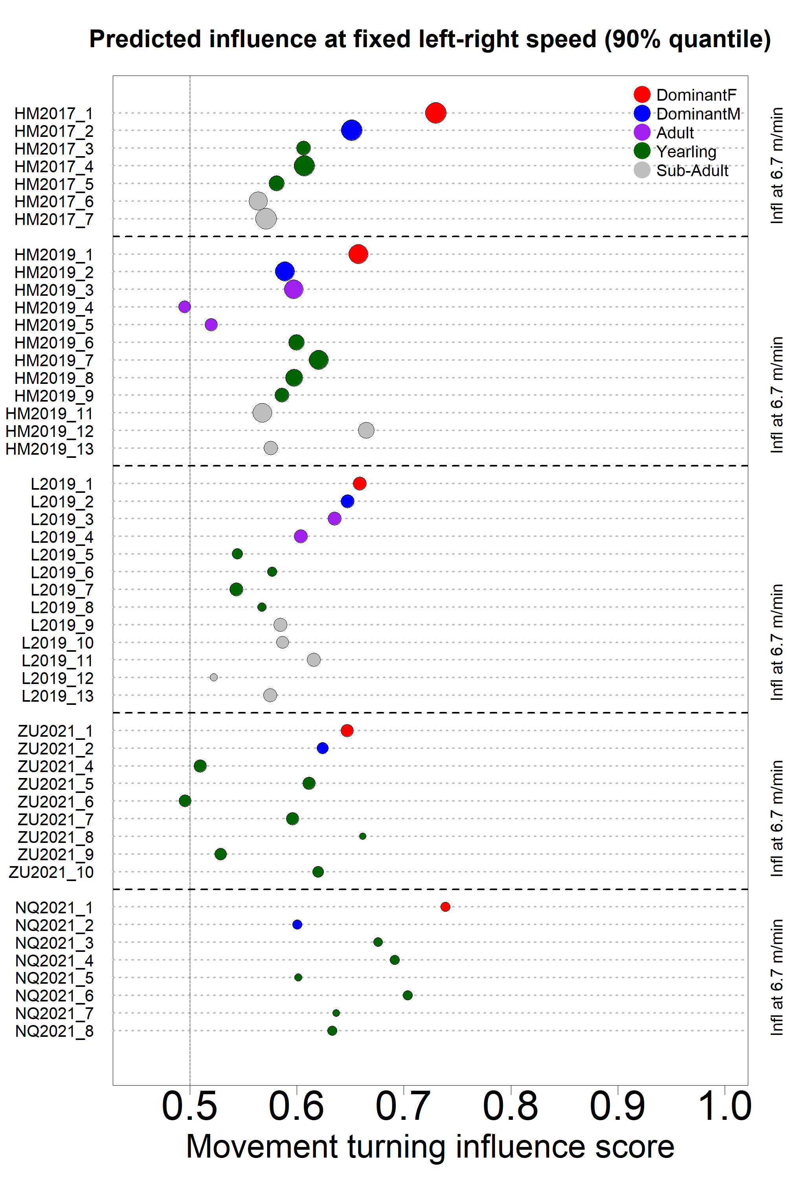

**a.**

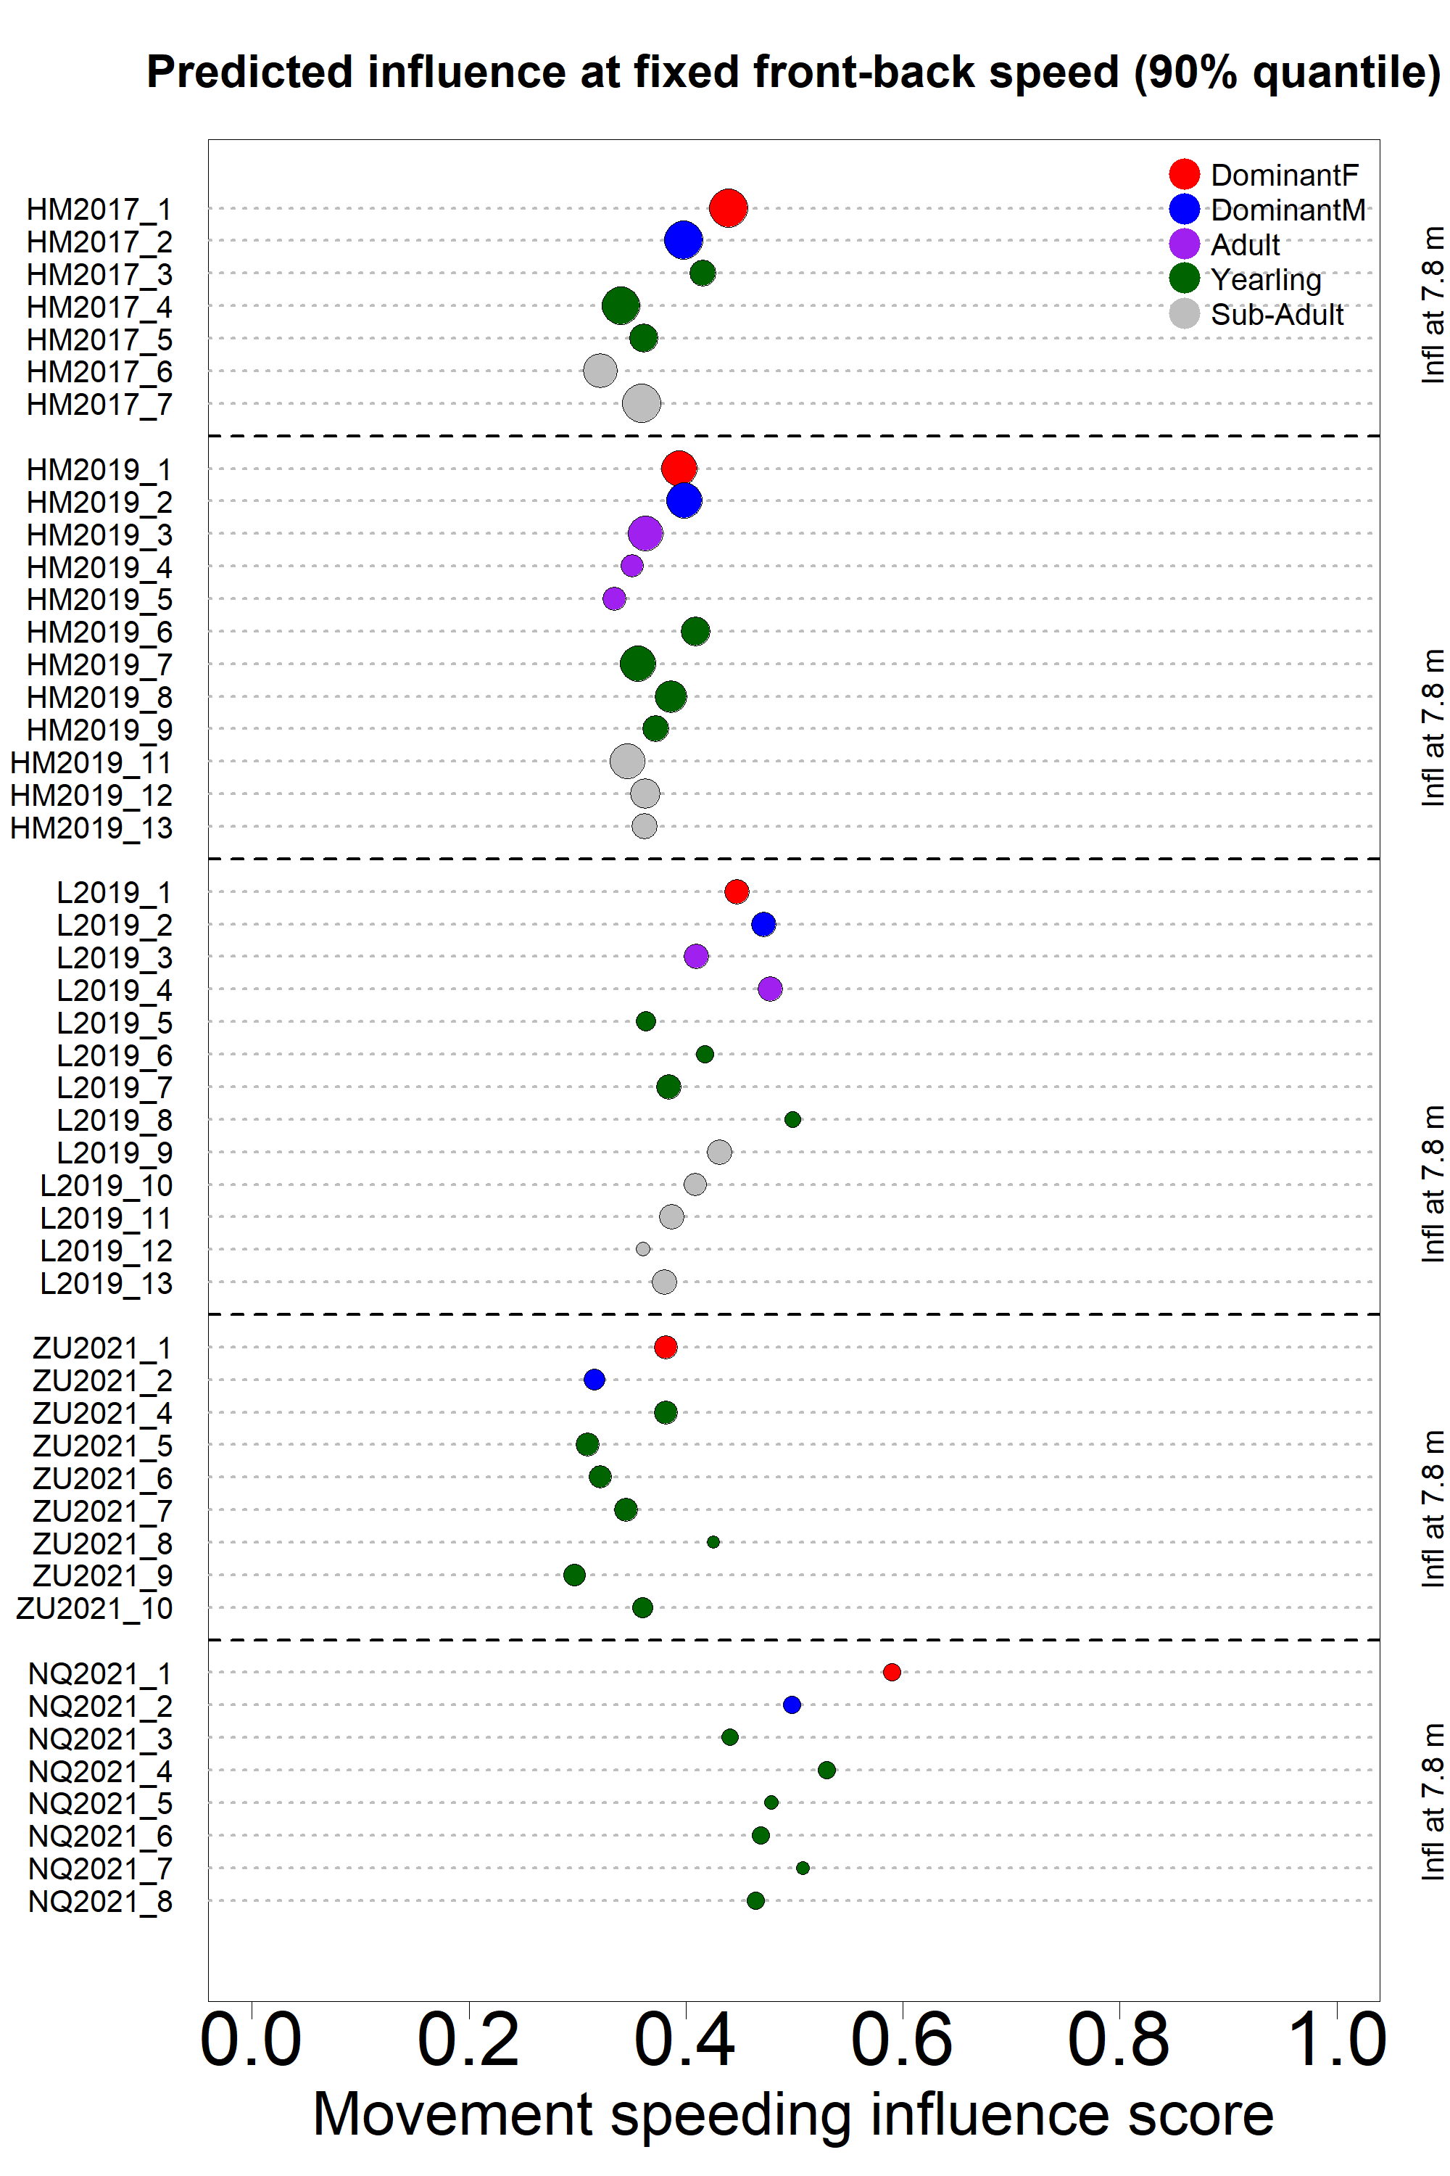

**b.**

Figure 5. Predicted influence scores for each recorded individual (colored dots) in the 5 study groups (vertical axis). Dot color indicates individual status as shown in the legend, dot size is proportional to the quantity of data available. (a) Turning influence score represents the probability that the group turns toward the same direction (left or right) that individual was moving to. (b) Speeding influence score represents the probability that the group speeds up after that individual had sped up towards the front of the group.

**Influence vs time spent in the front:**

We found that the association between the time spent in the front half of the group and the social status of individuals varied between groups (figure 6), with some showing a trend towards more time spent in the front by the dominant female (HM2017, HM2019, NQ2021), some showing the opposite effect (ZU21) and others no effect (L2019). The dominant male was always more in the back half of the group, except in L2019.

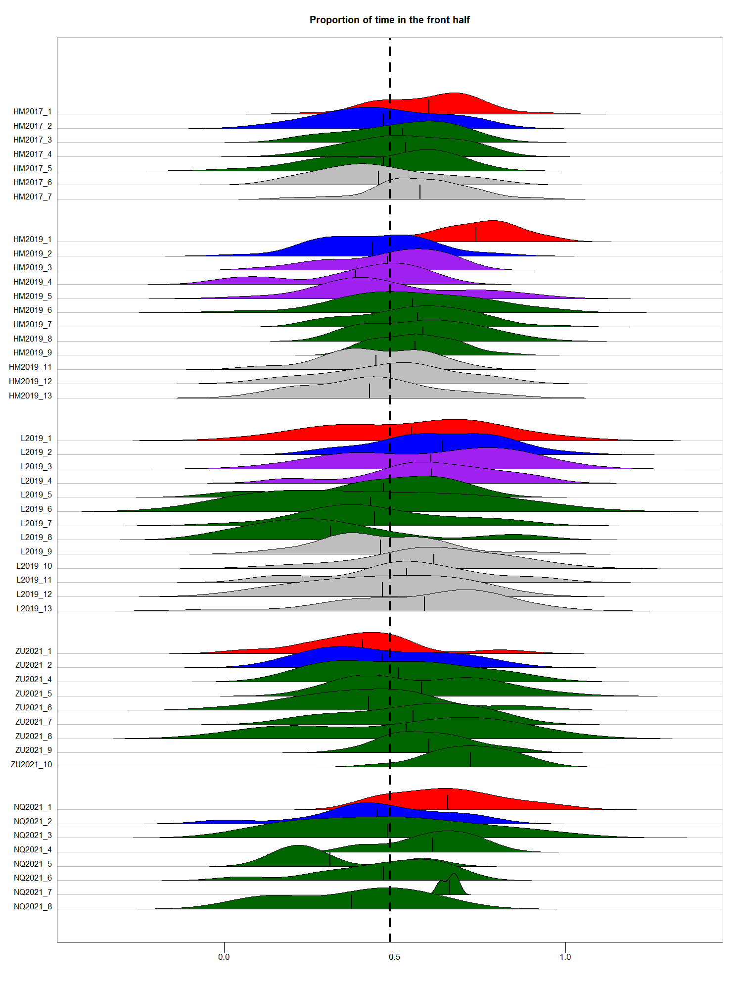

Figure 6. Distribution of the proportion of time points spent in the front half of the group over one-hour time period, for all individuals in the 5 study groups (vertical axis). Shape color indicates individual status as shown in the legend. Black vertical lines within each shape indicates the overall mean proportion of time spent in the front half of the group for that individual. Vertical dotted line indicates equal amount of time spent in the front and in the back half of the group.

We found a positive correlation between overall proportion of time spent in the front half and individual movement turning (figure 7.a: F=6.039, DF = 47, p-value = 0.01), but not speeding influence score (;figure 7.b: F=0.628, DF = 47, p-value = 0.432).

Figure 7. Individual movement turning influence score (a) and movement speeding influence score (b) as a function of proportion of time spent in the front half of the group. Each dot represents one individual, with color indicating status and shape indicating group membership.

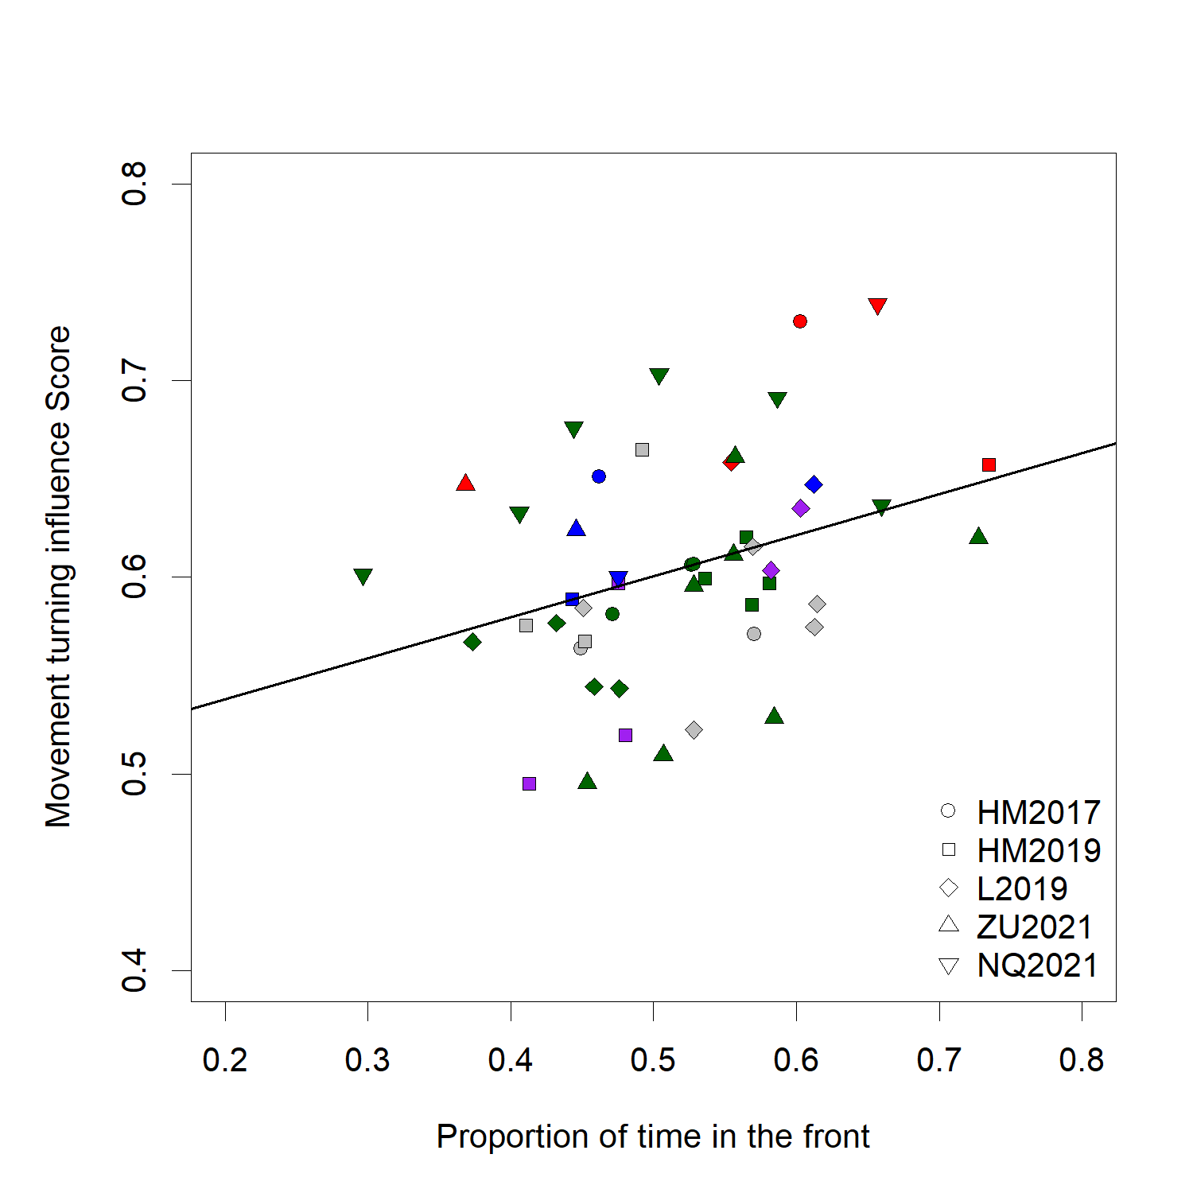

**a.**

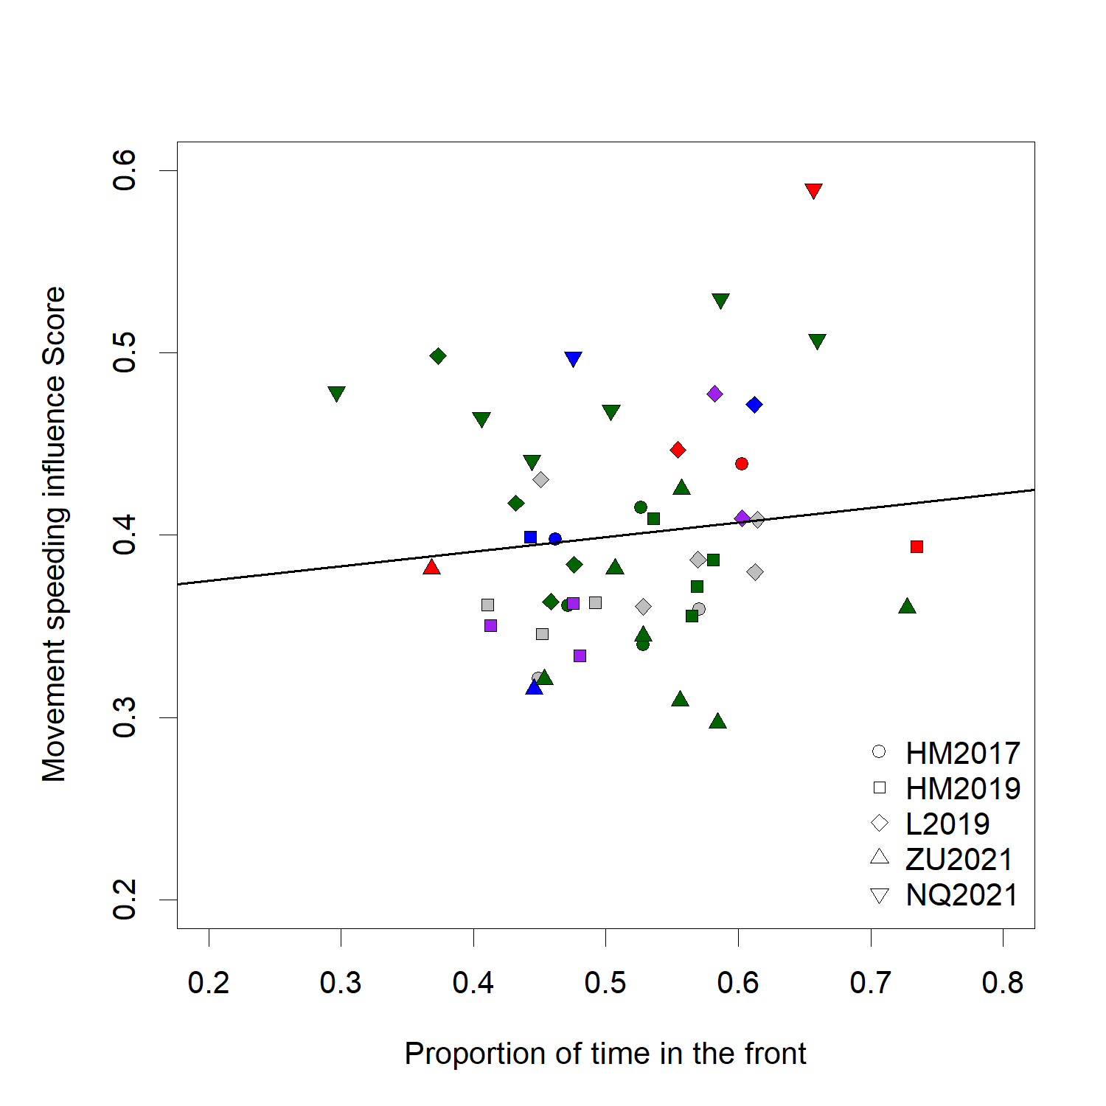

**b.**

**DISCUSSION**

In this study, we analyzed simultaneous movement trajectories of individuals in social groups of highly cohesive meerkats while foraging. We assessed whether the position and movement of individual animals affects the probability of the whole group to turn towards a given direction or to change its speed and compared the resulting influence scores between animals of different social status. We also tested, whether individuals with high influence scores were more likely to be in the front of the group. The comparison of five different groups as well as the use of different, complementary metrics to measure influence allow us to draw nuanced conclusions regarding the mechanisms of collective decision-making in meerkats.

We found that the speed and direction of movement of individuals, but not their position, was linked with the speed and direction of the rest of the group. This contradicts classical models of collective movement (REF) and controlled studies of moving animal groups (REF), that found individual position to be an important predictor of the group’s travel direction. However, our findings make sense in the light of the particular type of movement exhibited by meerkat groups. Contrary to animals in the studies cited above, which tend to be always in polarized motion and for which position is therefore a strong indicator of direction, individual meerkats forage independently while the group as a whole is relatively stationary. Thus, an individual’s position in the group does not necessarily indicate its desired travel direction. Our results indicate that individual meerkats are more likely to influence the group’s direction of movement, when they move with high speed in that particular direction. Individuals thus likely draw more information from the movement of others, than from their position. This result highlights the importance of considering species-specific collective movement patterns when studying movement decisions in animal groups.

When assessing the correlation between an individual’s social status and their influence on group movement, we found that the dominant female has significantly higher movement turning influence in all groups, meaning that others follow her direction of movement much more likely than they follow any other individual. Interestingly, no such effect was observed for the dominant male . One hypothesis as to why dominant females may control group direction more than dominant males is that females have more experience within the territory. Meerkat group territories vary little within the course of individual’s lives (Kranstauber et al. 2019), so individuals who have spent more time within a given group are the most experienced ones in terms of navigating within this group’s home range, and should thus be more likely to be followed by other less experienced individuals. Because males are generally the dispersing sex in meerkats, dominant males are typically non-natal and hence have usually not spent as much time in the group territory (S.P. Doolan and Macdonald 1996; Griffin et al. 2003; Mares et al. 2014). In all five groups we studied here, the dominant female was the eldest natal individual of the group, with the exception of NQ21, where two subordinate individuals were born in the same litter as the dominant female (NQ2021_3 and NQ2021_4). It is noteworthy that these individuals had fairly high turning influence scores, too. However, while we expected to observe that older individuals generally have more influence on group movement, we found no such trend when analyzing the remaining subordinate statuses (non-dominant adults, yearlings, and sub-adults). It is thus likely that both knowledge of the home range and dominance status contribute to a meerkat’s influence on the group’s direction of movement. This also highlights the benefits provided by the availability of long-term data in interpreting short-term results.

Individuals with high influence on group turning also tended to have high influence on group speed (see supplements), but we did not find that this type of influence was correlated to social status. In particular, all adult meerkats (dominant female, dominant male and other adults) had a similar chance of speeding the group up when they were moving faster than the centroid. Hence, the dominant female seems to have more influence over the direction of travel of the group than over its speed. Decisions about direction of movement and decisions about speed (i.e. timing) of movement usually differ in that the former are discrete whereas the latter are continuous (Conradt and Roper 2010). In the case of meerkats, this means that contrary to timing decision, wrong decisions regarding the direction of movement could end up being very costly for all individuals in the groups, as they could end up in a location with little food, or no sleeping burrows, or in rival territories. Thus, it makes sense that experienced individuals, such as the dominant females of the group, are more likely to influence decisions involving directions. Future analyses will have to show, whether influence over group speed is distributed (e.g. with all or most adults contributing to the group’s speed equally), or whether it varies in time, with individuals taking turn in influencing others to speed up or slow down. Because speed of the group affects the individuals’ ability to locate food, it is likely that individuals are not indifferent towards the group’s speed. It is possible that meerkats use a type of quorum mechanism, akin to a voting process to decide on the group’s speed, as has already been shown for decisions on departure time (Bousquet et al. 2011). Here, a certain threshold of individuals giving a specific type of call is required for the group to start moving. Future work on group movement speed in meerkats should thus include data about individual foraging success, as well as vocalizations.

The tendency to be in the front of the group is often taken as a proxy for leadership in studies of collective animal movement. In line with this, we found a positive correlation between movement turning influence and proportion of time spent in the front half of the group. However, while this effect was observed on a group level, dominant females specifically (e.g. the status with the highest influence within their group) were not always found to be more in the front than other members of their group. In particular, in L19, the dominant female spent a similar amount or less time in the front than many other individuals in her group, and in ZU21, she is the individual who spent the least amount of time in the front of the group, despite both having the highest turning influence score of the group. These results highlight that individuals in moving social groups don’t necessarily need to be at the front position in order to influence group direction. Being in the front is most likely linked to influence in environments where visibility is high and in species where information is transferred primarily through vision (e.g. fish, Strandburg-Peshkin et al. 2013; Rosenthal et al. 2015). However, in the Kalahari desert, tall sour grass or bushes often impede visibility (REF), and meerkats have the potential to convey information and influence others from anywhere in the group thanks to their highly developed vocal communication system. Hence, the ordering of individuals along the axis of movement is not a reliable metric to infer influence for all species and should be used in complement with other metrics. Interestingly, it is worth noting that the one dominant female which was spending more time in the back (group ZU21) had by far the longest tenure at the time of data collection amongst dominant females of our study (104 weeks against 38 weeks maximum, sees supplements). This could be an indication that as a female’s dominancy becomes better and better established within a group, they might become more and more able to influence the group from any position.

**CONCLUSION**

Overall, our results indicate several trends regarding influence dynamics in meerkat groups: 1) individuals can influence the direction and speed of the group by their movement in certain direction more than by their position within the group, 2) the dominant female has most influence over direction of travel but not necessarily over speed of travel, and 3) the most influential individuals are not always the one who are more in the front of the group. The methodology and results we presented highlight the versality of influence and therefore the need to study it from different perspectives, using more than one animal group if possible, and taking the species’ life history and movement characteristics into accoiunt. Since our method captured measures of influence aggregated over time, it could be interesting in future work to contrast it with complementary approaches, for instance identifying particular events in the trajectory, like sharp changes in direction or increases in speed during movement, in order to get a more complete pictures of the distribution and variability of influence in meerkats. Integrating the use of vocalizations within this framework would also likely prove very insightful. Our analysis framework (with potential expansions or adjustments) could be used in other systems with similar movement characteristics as meerkats to allow for cross-species comparisons of the mechanisms of influence on animal group movement.

**BIBLIOGRAPHY**

Bousquet CAH, Manser MB. 2011. Resolution of experimentally induced symmetrical conflicts of interest in meerkats. Animal Behaviour. 81(6):1101–1107. doi:10.1016/j.anbehav.2011.02.030.

Bousquet CAH, Sumpter DJT, Manser MB. 2011. Moving calls: a vocal mechanism underlying quorum decisions in cohesive groups. Proceedings of the Royal Society of London B: Biological Sciences. 278(1711):1482–1488. doi:10.1098/rspb.2010.1739.

Clutton-Brock TH, Brotherton PNM, O’Riain MJ, Griffin AS, Gaynor D, Kansky R, Sharpe L, McIlrath GM. 2001. Contributions to cooperative rearing in meerkats. Animal Behaviour. 61(4):705–710. doi:10.1006/anbe.2000.1631.

Clutton-Brock TH, Maccoll A, Chadwick P, Gaynor D, Kansky R, Skinner JD. 1999. Reproduction and survival of suricates (Suricata suricatta) in the southern Kalahari. African Journal of Ecology. 37(1):69–80. doi:10.1046/j.1365-2028.1999.00160.x.

Conradt L, Roper TJ. 2010. Deciding group movements: where and when to go. Behavioural processes. 84:675–677. doi:10.1016/j.beproc.2010.03.005.

Couzin ID, Krause J, Franks NR, Levin SA. 2005. Effective leadership and decision-making in animal groups on the move. Nature. 433(7025):513–516. doi:10.1038/nature03236.

Doolan S, Macdonald D. 1996. Diet and foraging behaviour of group living meerkats, Suricata suricatta, in the southern Kalahari. Journal of Zoology. 239:697–716.

Doolan SP, Macdonald DW. 1996. Dispersal and extra-territorial prospecting by slender-tailed meerkats (Suricata suricatta) in the south-western Kalahari. Journal of Zoology. 240(1):59–73. doi:10.1111/j.1469-7998.1996.tb05486.x.

Doolan SP, Macdonald DW. 1997. Breeding and juvenile survival among slender-tailed meerkats (Suricatu suricatta) in the south-western Kalahari: ecological and social influences. Journal of Zoology. 242(2):309–327. doi:10.1111/j.1469-7998.1997.tb05804.x.

Gall GEC, Manser MB. 2017. Group cohesion in foraging meerkats : follow the moving ‘ vocal hot spot ’. Royal Society Open Science.

Gall GEC, Strandburg-Peshkin A, Clutton-brock T, Manser MB. 2017. As dusk falls : collective decisions about the return to sleeping sites in meerkats. 132:91–99.

Garland J, Berdahl AM, Sun J, Bollt EM. 2018. Anatomy of leadership in collective behaviour. Chaos. 28(7):075308. doi:10.1063/1.5024395.

Giuggioli L, McKetterick TJ, Holderied M. 2015. Delayed Response and Biosonar Perception Explain Movement Coordination in Trawling Bats. PLOS Computational Biology. 11(3):e1004089. doi:10.1371/journal.pcbi.1004089.

Griffin AS, Pemberton JM, Brotherton PNM, McIlrath G, Gaynor D, Kansky R, O’Riain J, Clutton-Brock TH. 2003. A genetic analysis of breeding success in the cooperative meerkat (Suricata suricatta). Behavioral Ecology. 14(4):472–480. doi:10.1093/beheco/arg040.

Herbert-Read JE. 2016. Understanding how animal groups achieve coordinated movement. Journal of Experimental Biology. 219(19):2971–2983. doi:10.1242/jeb.129411.

Hughey LF, Hein AM, Strandburg-Peshkin A, Jensen FH. 2018. Challenges and solutions for studying collective animal behaviour in the wild. Phil Trans R Soc B. 373(1746):20170005. doi:10.1098/rstb.2017.0005.

Jolles JW, Boogert NJ, Sridhar VH, Couzin ID, Manica A. 2017. Consistent Individual Differences Drive Collective Behavior and Group Functioning of Schooling Fish. Current Biology. 27(18):2862-2868.e7. doi:10.1016/j.cub.2017.08.004.

Katz Y, Tunstrøm K, Ioannou CC, Huepe C, Couzin ID. 2011. Inferring the structure and dynamics of interactions in schooling fish. PNAS. 108(46):18720–18725. doi:10.1073/pnas.1107583108.

Kerth G, Ebert C, Schmidtke C. 2006. Group decision making in fission–fusion societies: evidence from two-field experiments in Bechstein’s bats. Proceedings of the Royal Society B: Biological Sciences. 273(1602):2785–2790. doi:10.1098/rspb.2006.3647.

Kranstauber B, Gall GEC, Vink T, Clutton‐Brock T, Manser MB. 2019. Long-term movements and home-range changes: Rapid territory shifts in meerkats. Journal of Animal Ecology. n/a(n/a). doi:10.1111/1365-2656.13129. [accessed 2019 Dec 19]. https://besjournals.onlinelibrary.wiley.com/doi/abs/10.1111/1365-2656.13129.

Lewis JS, Wartzok D, Heithaus MR. 2011. Highly dynamic fission–fusion species can exhibit leadership when traveling. Behav Ecol Sociobiol. 65(5):1061–1069. doi:10.1007/s00265-010-1113-y.

Manser MB, Clutton‐Brock TH. 2016. Meerkats: cooperative breeding in the Kalahari. In: Koenig WD, Dickinson JL, editors. Cooperative Breeding in Vertebrates. Cambridge University Press.

Manser MB, Jansen DAWAM, Graw B, Hollén LI, Bousquet CAH, Furrer RD, le Roux A. 2014. Vocal Complexity in Meerkats and Other Mongoose Species.

Mares R, Bateman AW, English S, Clutton-Brock TH, Young AJ. 2014. Timing of predispersal prospecting is influenced by environmental, social and state-dependent factors in meerkats. Animal Behaviour. 88:185–193. doi:10.1016/j.anbehav.2013.11.025.

Montanari D, O’Hearn WJ, Hambuckers J, Fischer J, Zinner D. 2021. Coordination during group departures and progressions in the tolerant multi-level society of wild Guinea baboons (Papio papio). Sci Rep. 11(1):21938. doi:10.1038/s41598-021-01356-6.

Nagy M, Ákos Z, Biro D, Vicsek T. 2010. Hierarchical group dynamics in pigeon flocks. Nature. 464(7290):890–893. doi:10.1038/nature08891.

Papageorgiou D, Farine DR. 2020. Shared decision-making allows subordinates to lead when dominants monopolize resources. Science Advances. 6(48):eaba5881. doi:10.1126/sciadv.aba5881.

Pettit B, Ákos Z, Vicsek T, Biro D. 2015. Speed Determines Leadership and Leadership Determines Learning during Pigeon Flocking. Current Biology. 25(23):3132–3137. doi:10.1016/j.cub.2015.10.044.

Rosenthal SB, Twomey CR, Hartnett AT, Wu HS, Couzin ID. 2015. Revealing the hidden networks of interaction in mobile animal groups allows prediction of complex behavioral contagion. PNAS. 112(15):4690–4695. doi:10.1073/pnas.1420068112.

Smith JE, Estrada JR, Richards HR, Dawes SE, Mitsos K, Holekamp KE. 2015. Collective movements, leadership and consensus costs at reunions in spotted hyaenas. Animal Behaviour. 105:187–200. doi:10.1016/j.anbehav.2015.04.023.

Strandburg-Peshkin A, Clutton-Brock T, Manser MB. 2020. Burrow usage patterns and decision-making in meerkat groups. Behavioral Ecology. 31(2):292–302. doi:10.1093/beheco/arz190.

Strandburg-Peshkin A, Clutton-Brock T, Manser MB. 2019. Burrow usage patterns and decision-making in meerkat groups. Behav Ecol. doi:10.1093/beheco/arz190. [accessed 2019 Nov 8]. https://academic.oup.com/beheco/advance-article/doi/10.1093/beheco/arz190/5613753.

Strandburg-Peshkin A, Farine DR, Couzin ID, Crofoot MC. 2015. GROUP DECISIONS. Shared decision-making drives collective movement in wild baboons. Science. 348(6241):1358–1361. doi:10.1126/science.aaa5099.

Strandburg-Peshkin A, Papageorgiou D, Crofoot MC, Farine DR. 2018. Inferring influence and leadership in moving animal groups. Philosophical transactions of the Royal Society of London Series B, Biological sciences. 373(1746):20170006–20170006. doi:10.1098/rstb.2017.0006.

Strandburg-Peshkin A, Twomey CR, Bode NWF, Kao AB, Katz Y, Ioannou CC, Rosenthal SB, Torney CJ, Wu HS, Levin SA, et al. 2013. Visual sensory networks and effective information transfer in animal groups. Current Biology. 23(17):R709–R711. doi:10.1016/j.cub.2013.07.059.

Tokuyama N, Furuichi T. 2017. Leadership of old females in collective departures in wild bonobos (Pan paniscus) at Wamba. Behav Ecol Sociobiol. 71(3):55. doi:10.1007/s00265-017-2277-5.

Van Belle S, Estrada A, Garber PA. 2013. Collective group movement and leadership in wild black howler monkeys (Alouatta pigra). Behav Ecol Sociobiol. 67(1):31–41. doi:10.1007/s00265-012-1421-5.